Bash Script/ Shell Script

Step 1 . Create file **filename.sh**

Step 2. Write content in filename.sh with starting line **#!/bin/bash**

Step 3. Change mode of file to executable ny command **chmod u+x filename.sh**

Step 4. Execute the file by command **./filename.sh**

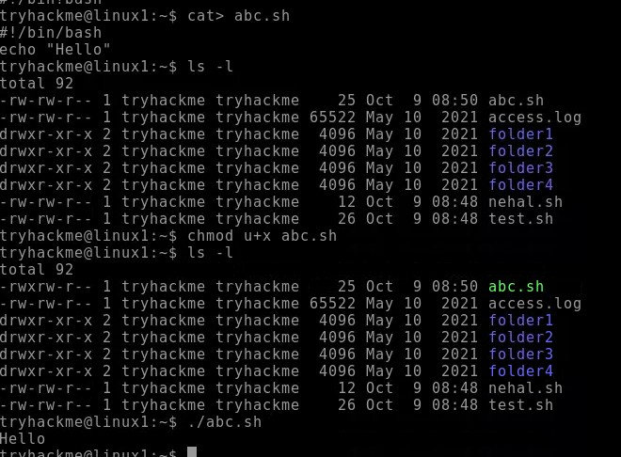

Take Input from user

**read input_name**

If we want to execute the use **$input_name**

* 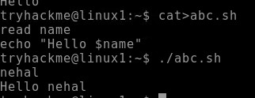Taking string value as input
* 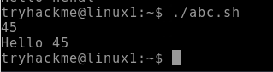Taking numeric value as input
* Add two numeric value

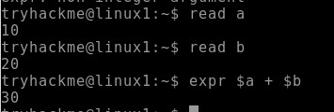

* + 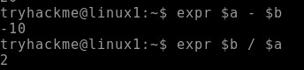Arithmetic operation